DEEP VEIN THROMBOSIS

Definition:

- Development of single or multiple blood clots within the deep veins of the extremities or pelvis, usually accompanied by inflammation of the vessel wall.
- Thrombosis of the deep veins occurs most often in the calf but may also occur in the thigh or pelvis
- It may be primary or an extension of more peripheral disease.
- Most cases in pregnancy are confined to the deep veins of the lower extremity
- Proximal vein thrombosis are iliac or femoral vein
- Calf vein thrombosis is distal vein thrombosis

Etiology:

- Three generic factors promote clotting

a) Hypercoagulable states

- Cancer
- Nephrotic syndrome
- Sepsis
- Inflammatory conditions
  - Ulcerative colitis
- Increased estrogen
  - Pregnancy
  - Oral contraceptives
- Antiphospholipid syndrome
- Protein deficiencies
  - Protein S
  - Protein C
  - Antithrombin III
- Newer hypercoagulable states
  - Factor V
  - Leiden
  - Prothrombin gene mutations

b) Stasis

- Prolonged bed rest
- Immobility from a cast
- Long plane or train ride
- Neurologic disorders with paralysis
- Congestive heart failure
- Obesity

c) Vascular damage

- Trauma
- Surgery
- Central lines
  - Especially in the case of upper extremity thrombophlebitis

d) Multifactorial issues

- Advancing age
- Prior thromboembolism

Epidemiology

- Venous thromboembolism (VTE) complicates between 1 in 500 and 1 in 2000 pregnancies and is more common postpartum than antepartum
- Among pregnant women, the highest risk period for venous thromboembolism and pulmonary embolism in particular is during the postpartum period
- Antepartum VTE is currently roughly equally distributed across trimesters
- The risk of deep vein thrombosis (DVT) is approximately twice as high after cesarean delivery than vaginal birth
- In addition, DVT is more common in the left than the right leg.
- There is a striking propensity for the left leg, with approximately 80% of DVT’s in pregnancy occurring on this side
- This striking distribution has been attributed to increased venous stasis in the left leg related to compression of the left iliac vein by the right iliac artery, coupled with compression of the inferior vena cava by the gravid uterus itself
- The venous drainage of the left leg follows a more tortuous course through the pelvis, with the left common iliac vein traversed by the right common iliac artery.
- It has been suggested that this renders the left leg more prone to DVT.

Risk factors:

- Advanced age (Usually over 40)
- Obesity
- Cancer
- Pregnancy
- Oral contraceptive use (oral contraceptives and replacement estrogens)
- Hyperlipidemia
- Diabetes
- Hemoconcentration following transfusion for severe anemia
- Certain hypercoagulable states (protein C and S deficiencies, hyperhomocysteinemia)
- Recently, the factor V Leiden mutation has been implicated as a potential important cause.
- The puerperium has been known as the time when severe thrombophlebitic conditions and pulmonary embolism occur, probably as a result of the once-prevalent recommendation of prolonged bedrest following parturition.
- The risk of recurrence in a subsequent pregnancy is substantial
- The risk of deep vein thrombosis (DVT) is approximately twice as high after cesarean delivery than vaginal birth

Pathogenesis:

- Pregnancy and the postpartum period may be marked by the presence of all three components of Virchow's triad: venous stasis, endothelial injury, and a hypercoagulable state
- Stasis: Venous stasis of the lower extremities occurs because of two factors: pregnancy-associated changes in venous capacitance and compression of large veins by the gravid uterus.
- The linear flow velocity in the lower extremity veins is decreased, probably due to hormonally induced dilation of capacitance veins, which leads to venous pooling and valvular incompetence
- These early changes are amplified by inferior vena caval compression by the gravid uterus
- Endothelial injury: Delivery is associated with vascular injury and changes at the uteroplacental surface, which probably accounts for the frequency of VTE in the immediate postpartum period.
- Forceps, vacuum extraction, or surgical delivery can exaggerate vascular intimal injury and amplify this phenomenon
- Hypercoagulability: Pregnancy is a hypercoagulable state associated with progressive increases in several coagulation factors, such as factors I, II, VII, VIII, IX, and X, along with a decrease in protein S
- A progressive increase in resistance to activated protein C is normally observed in the second and third trimesters
- Activity of the fibrinolytic inhibitors PAI-1 and PAI-2 is increased during pregnancy, although total fibrinolytic activity may not be impaired
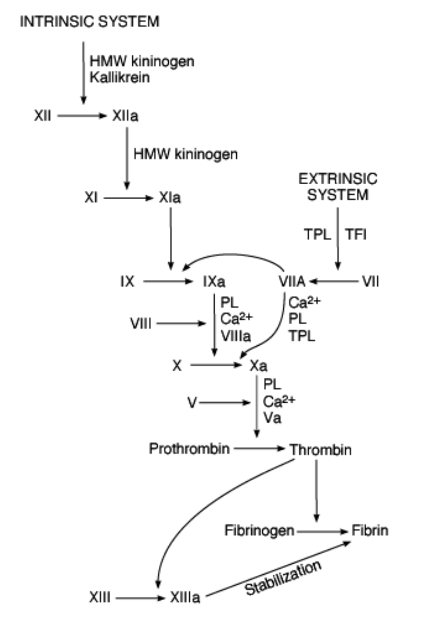
- The presence of antiphospholipid antibodies also predisposes women to thrombosis, especially during pregnancy or with use of oral contraceptives.
- A constant balance exists between intravascular clot-promoting and clot-dissolving forces.
- When the former overpowers the latter, clot results.
- Endothelial injury can expose collagen, causing platelet aggregation and tissue thromboplastin release that, when stasis or hypercoagulability is present, trigger the coagulation mechanism
- Tissue thromboplastin is released, forming thrombin and fibrin that trap RBCs and propagate proximally as a red or fibrin thrombus, which is the predominant morphologic venous lesion (the white or platelet thrombus is the principal component of most arterial lesions)
- When a small blood vessel is transected or damaged, the injury initiates a series of events that leads to the formation of a clot (hemostasis)
- The initial event is constriction of the vessel and formation of a temporary hemostatic plug of platelets that is triggered when platelets bind to collagen and aggregate.
- This is followed by conversion of the plug into the definitive clot.
- The loose aggregation of platelets in the temporary plug is bound together and converted into the definitive clot by fibrin.
- The clotting mechanism responsible for the formation of fibrin involves a cascade of reactions in which inactive enzymes are activated, and the activated enzymes in turn activate other inactive enzymes.
- The fundamental reaction in the clotting of blood is conversion of the soluble plasma protein fibrinogen to insoluble fibrin
- The conversion of fibrinogen to fibrin is catalyzed by thrombin

Clinical presentation:

- The signs and symptoms of deep venous thrombosis involving the lower extremity vary greatly, depending in large measure upon the degree of occlusion and the intensity of the inflammatory response.
- The patient may complain of a dull ache or frank pain in the leg or calf.
- There may be tenderness or spasm in the calf muscle.
- Leg swelling-Greater than 2 cm difference is usually significant
- Leg warmth and redness
- Palpable cord
- Phlegmasia cerulea dolens-Cold, tender, swollen and blue leg (secondary arterial insufficiency)
- Phlegmasia alba dolens-Cold, tender and white leg (secondary arterial insufficiency)
- Dorsiflexion of the foot may elicit pain in the calf (Homans' sign).
- Although a positive Homans' sign is specific, the test is not very sensitive (about 25%).
- Slight elevation of the temperature and pulse is frequently noted.
- If the clot is in the femoral vein or in the pelvis, swelling of the extremity may be more severe.
- Classical puerperal thrombophlebitis involving the lower extremity, sometime called phlegmasia alba dolens or milk leg, is abrupt in onset, with severe pain and edema of the leg and thigh.
- Occasionally, reflex arterial spasm causes a pale, cool extremity with diminished pulsations.
- More likely, there may be appreciable volume of clot yet little reaction in the form of pain, heat, or swelling.
- The major complication of deep thrombophlebitis is pulmonary embolism.
- Chronic venous insufficiency may develop as a long-term consequence.

Diagnosis:

- Compression ultrasonography or impedance plethysmography usually provides a definite diagnosis.
- Real-time ultrasonography, used along with duplex and color Doppler ultrasound, is currently the procedure of choice to detect proximal deep vein thrombosis
- Both are noninvasive and are sensitive and specific.
- If these tests are not diagnostic, contrast venography is the gold standard and should be performed.
- Although venography or phlebography remains the standard for confirmation of deep venous thrombosis, noninvasive methods have largely replaced this test to confirm the clinical diagnosis
- In pregnant women, thrombosis associated with pulmonary embolism frequently originates in the iliac veins.

Treatment

- What are the aims of the treatment of DVT?
- Aims are:
- To prevent extension of the thrombus.
- To restore venous patency and thus in the long run to prevent the post-phlebitic syndrome due to venous insufficiency with features like chronic pain, swelling, and sometimes ulceration of the affected limb.
- The most important aim is to prevent pulmonary embolisation or its recurrence.

1. Medical treatment

- Once the diagnosis of a significant deep vein thrombosis extending into the veins proximal to the calf has been made, anticoagulants should be started immediately.
- Traditionally, intravenous unfractionated heparin has been the first-line therapy.
- Recently, subcutaneous low molecular weight heparin has gained acceptance.
- Coagulation studies, including international normalized ratio (INR) and partial thromboplastin time (PTT), should be done before anticoagulant therapy is started; these tests provide a basis for interpreting the degree of anticoagulation achieved with unfractionated heparin.
- When using unfractionated heparin, the PTT should be kept to 2-3 times the control value.
- The more predictable bioavailability, clearance, and activity of low molecular weight heparins obviates the need for laboratory monitoring except in unusual circumstances.
- Intravenous protamine sulfate can be used in emergencies to counteract the effects of heparin.
- Heparin should be continued at least 3-5 days after the disappearance of all signs and symptoms and effective long-term therapy has been established.
- Oral anticoagulants such as dicumarol and warfarin are contraindicated in pregnant patients but are often started at the same time as heparin in other patients.
- Started shortly after a heparin has been administered.
- Not before heparin because of the theoretic risk for inducing a transient hypercoagulable state
- The therapeutic effect of these agents is measured by the INR.
- Whereas heparin prolongs the clotting time almost immediately, the oral anticoagulants do not exert their full effect for 48-72 hours.
- Heparin is usually started for its immediate short-term effect, and then replaced with oral anticoagulants for long-term treatment.
- Once-daily low molecular weight heparin can be used long-term in patients for whom bleeding is a particular risk or laboratory monitoring is problematic
- If using warfarin, the INR should be determined daily until equilibrium levels of 2.0-3.0 are attained.
- Emergency reversal can be achieved with 2 units of fresh frozen plasma.
- Anticoagulation is usually continued empirically for 3 months.
- Possible complications of therapy, including hematuria, hemoptysis, hematemesis, melena, and easy bruisability
- Patients should also be given a list of over-the-counter medications to avoid, including nonsteroidal anti-inflammatory drugs, aspirin, and antibiotics, which may affect their anticoagulation.

Heparin

  - Types: Unfractionated heparin, a naturally occurring mucopolysaccharide is the anticoagulant used most widely for DVT in pregnancy.
  - Unfractionated heparin (as distinguished from low-molecular-weight heparin) has a high molecular weight which precludes transplacental transfer.
- LMW heparin: These are fragments of conventional heparin produced by enzymatic or chemical breakdown.
- Like heparin they do not cross placenta, are nonteratogenic and are not secreted in milk.
- By virtue of their shorter and lighter structures, LMWHs produce a predominantly anti-thrombotic effect through their inhibition of factor Xa with little anticoagulant activity.
- No need for lab. monitoring for coagulation tests like PT and aPTT
- Currently use of LMWHs in pregnancy is mainly confined to the chronic phase of treatment and to thrombophylaxis.
- Mechanism of action: In plasma, it combines with antithrombin III to become a potent inhibitor of thrombin and to increase the circulating levels of activated factor X inhibitor.
- Adjust dosage based on activated partial thromboplastin time (aPTT) to achieve aPTT of approximately 3x control.
- The goal of maintenance heparin therapy is to maintain the aPTT in the range of 1.5 to 2.5 times the patient's aPTT baseline value.
- Optimal anticoagulation is obtained with an aPTT of 60-80 sec (1.5 to 2.5 times control).
- Dosage: For patients with uncomplicated DVT, the loading dose is 100 U/kg with a minimum of 5,000 units.
- Following it, the initial infusion rate should be 15-25 units/Kg/hour.
- If complicated 400-500U/Kg loading dose
- An aPTT should be obtained 4 hours after the loading dose and appropriate adjustment should be made.
- Continuous IV infusion of heparin should be administered for 3-5 days for active thromboembolic disease or until symptoms have resolved and there is no recurrence.
- It is followed by adjusted dose regimen of heparin for 4-6 months followed by a prophylactic dose for the remainder of pregnancy and 6-12 weeks postpartum.
- An adjusted dose regimen is accomplished by administration of heparin s c every 12 hr. and adjustment of dose to achieve an aPTT of 1.5-2 times control at 6 hrs.
- Once a stable dosage is reached, a mid-interval aPTT should be checked weekly at the pre-natal visits.
- It should be anticipated that heparin requirements would increase during pregnancy until term.
- LMW: Full anticoagulation doses of LMWH are :ENOXAPARIN 1 mg/kg SC bd and DALTEPARIN 100 iu/kg SC bd
- Reversal: If necessary, heparin effects can be reversed rapidly with protamine sulfate in a dose of 1 mg/100 units of administered heparin.
- No more than 50 mg should be given over any 10 min. period because it itself can cause bleeding.
- Stop: Anticoagulation during labour is not indicated.
- Patient can be instructed to discontinue therapy with the onset of labour.
- Therapy should be restarted promptly 4-6 hrs postpartum.
- Regional anaesthesia is not contraindicated if aPTT is normal and heparin has not been administered within 4-6 hr. of procedure
- If anticoagulation is required during delivery, the dose should be adjusted to achieve an aPTT of 1.5 times control during labour and delivery
- Side effects: Heparin does not cross placenta so there are no foetal hazards.
- However, its long-term use, as is required in DVT, can have some adverse effects in the mothers.
- Bleeding is an obvious risk with any anticoagulant
- Subcutaneous heparin can cause persistent anticoagulation after cessation of use.
- Therefore it is recommended that subcutaneous heparin be converted to IV heparin 24 hr. before elective induction of labour
- Osteoporosis: It is particularly relevant to pregnancy because heparin treatment is frequently prolonged.
- Thrombocytopenia: It exists in 2 forms – an early benign form with mild thrombocytopenia occurring after one to several days of treatment and delayed condition which occurs 6-10 days after commencing treatment.
- The latter is an immunemediated reaction associated with severe thrombocytopenia, paradoxical arterial or venous thromboses with significant morbidity and mortality and requires immediate withdrawal of heparin treatment.
- Patients on long term heparin treatment should have their platelet count checked 1 week after commencing treatment and monthly thereafter.

Warfarin:

- Mechanism of action: The anticoagulant effect of warfarin is mediated by interference with the vitamin K-dependent gamma-carboxylation of coagulation factors II, VII, IX, and X, and proteins C and S
- This results in the synthesis of immunologically detectable but biologically inactive forms of these coagulation proteins.
- The anticoagulant effect of warfarin is delayed until the normal clotting factors are cleared from the circulation, and the peak effect does not occur until 36 to 72 hours after drug administration
- Adverse effects: Warfarin use during pregnancy is limited by the fact that it crosses placenta
- Adverse fetal effects from warfarin may result from the teratogenicity of the drug and its propensity to cause bleeding in the fetus.
- There is convincing evidence that warfarin administration between the sixth and ninth weeks of gestation is potentially teratogenic, and associated with higher rates of spontaneous abortion and stillbirth
- The most common developmental abnormalities affect bone and cartilage; these simulate chondromalacia punctata, with stippled epiphyses and nasal and limb hypoplasia
- Dosage: Usual anticoagulation dose is 10-15mg daily until a therapeutic prolongation of prothrombin time (PT) is achieved.
- An appropriate International Normalisation Ratio (INR Patient PT ÷ Control PT) is 2.0-3.0.
- Initially PT is monitored daily for 5-7 days then twice weekly for 1-2 weeks and then weekly for several months depending on the response.
- Large loading doses should be avoided because of the increased likelihood of overcoagulation or quite possibly an early prothrombotic effect due to excessive protein C inhibition.
- During the first 5-7 days of warfarin therapy, heparin needs to be continued because its action is not immediate, as it is dependent on the synthesis of clotting factors.
- It is not secreted in the milk, thus is safe for use during lactation.
- If used during pregnancy, it should be replaced by heparin after 36 weeks or at the onset of labour.
- If spontaneous labour occurs while the patient is still taking warfarin, administering vitamin K and fresh frozen plasma can reverse its effect

2. Local measures

- Local measures include elevation of the legs to provide good venous drainage and the application of full-leg gradient-pressure elastic hose.
  - Bed rest with elevation of the affected extremity is invaluable initially because it promotes venous return and decreases oedema.
  - When inflammation has subsided, usually within 1-2 weeks of starting therapy, full activities may be permitted.
  - As soon as symptoms permit, the patient should be encouraged to ambulate, since bed rest itself may enhance venous stasis.
  - The patient should be encouraged to continue to elevate her legs whenever she can.
  - Prolonged sitting and the use of constrictive garments, especially knee-high support stockings or hosiery, is to be avoided.
  - When correctly designed, elastic stockings increase the velocity of venous flow.
  - The pressure gradient should decrease from ankle to thigh without a constricting garter at the top.

3. Surgical treatment

- Thrombectomy occasionally may be considered for persistent severe swelling of the extremity.
- An inferior vena cava filter or vena cava ligation may be considered for repeated episodes of pulmonary embolism that occur in spite of adequate anticoagulation or when anticoagulation is absolutely contraindicated.

Why most on the left side of the leg?

- The inferior vena cava is formed by the union of the right and left common iliac veins on the right side of the body of vertebra L5. It ascends in front of the vertebral column, on the right side of the aorta.
- Anterior relation: Right common iliac artery. On the left side the left common iliac artery crosses over the left common iliac vein causing it compression.
- The left common iliac vein crosses of the vertebral body from right cause of the inferior vena cover to the left, hence it compression by the gravid uterus over the vertebral body eminence.

